**Express**

**Express is a framework that helps us to easily manage our routing requests server-side logic and responses in a much more elegant way it makes our code easier to read and update and extend.**

**Express is really good it saves us time allows us to write clean code and it comes with some extra features that really help us out.**

**npm install express – for installing express.**

**Creating an Express App**

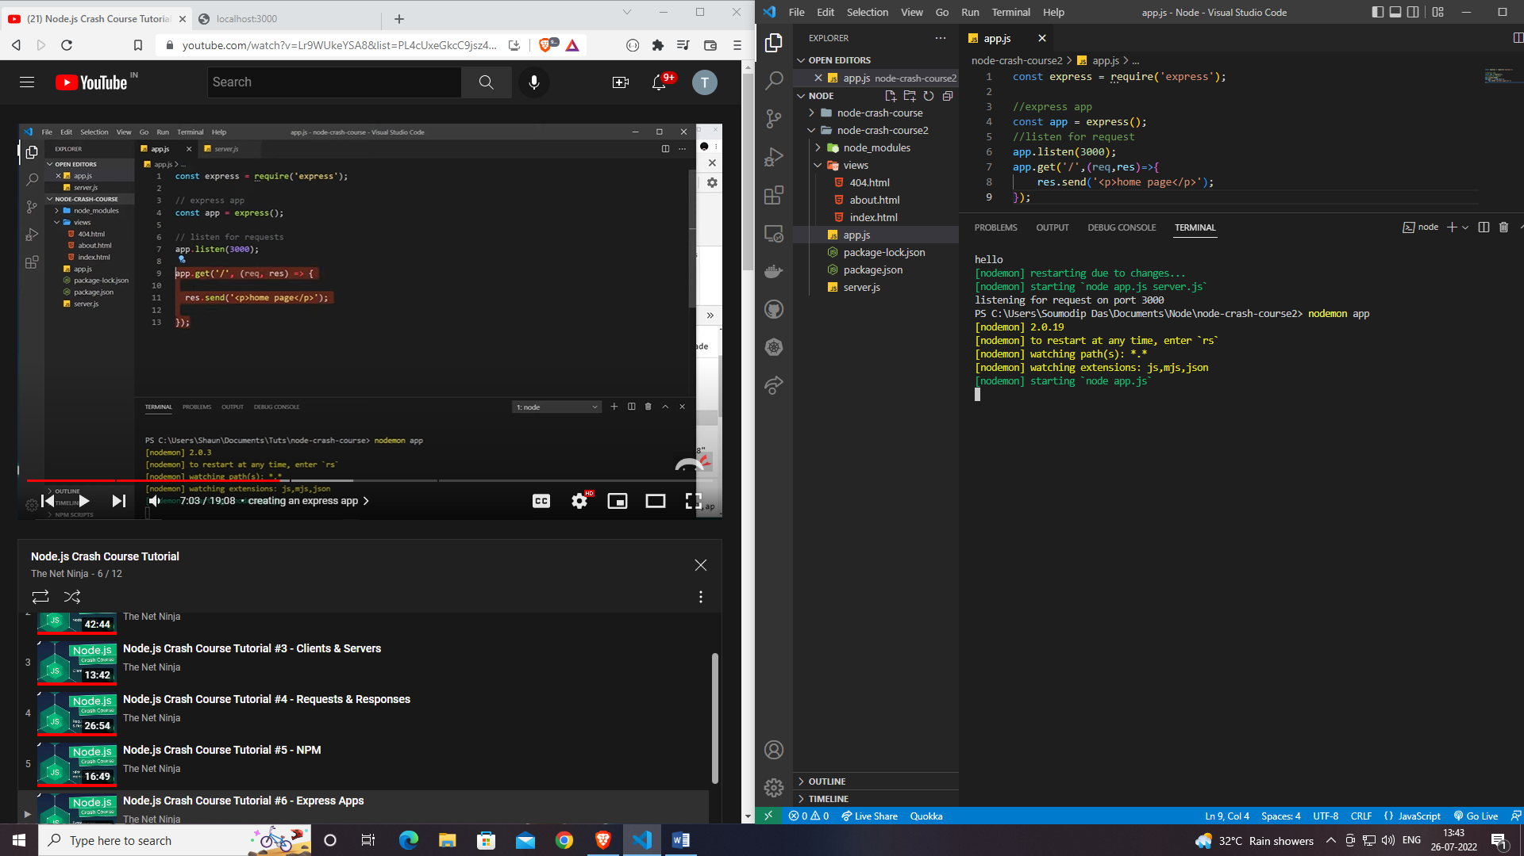

**Routing & HTML**

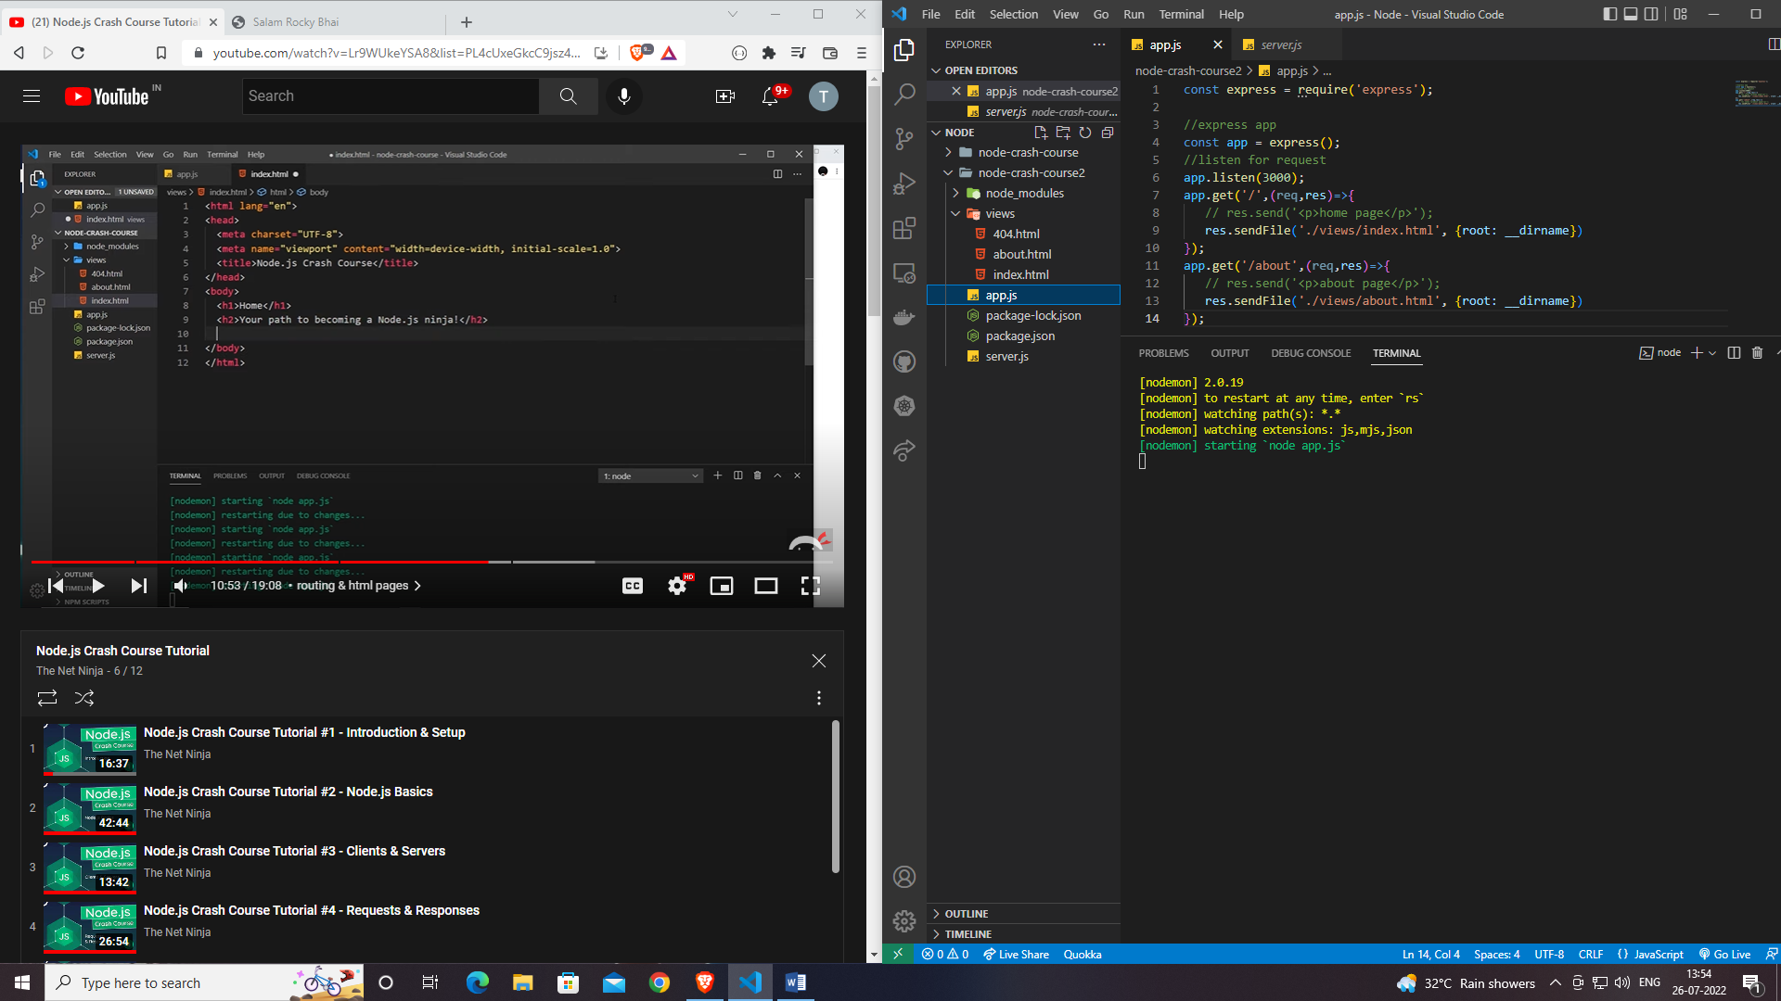

**Linking a page with another page.**

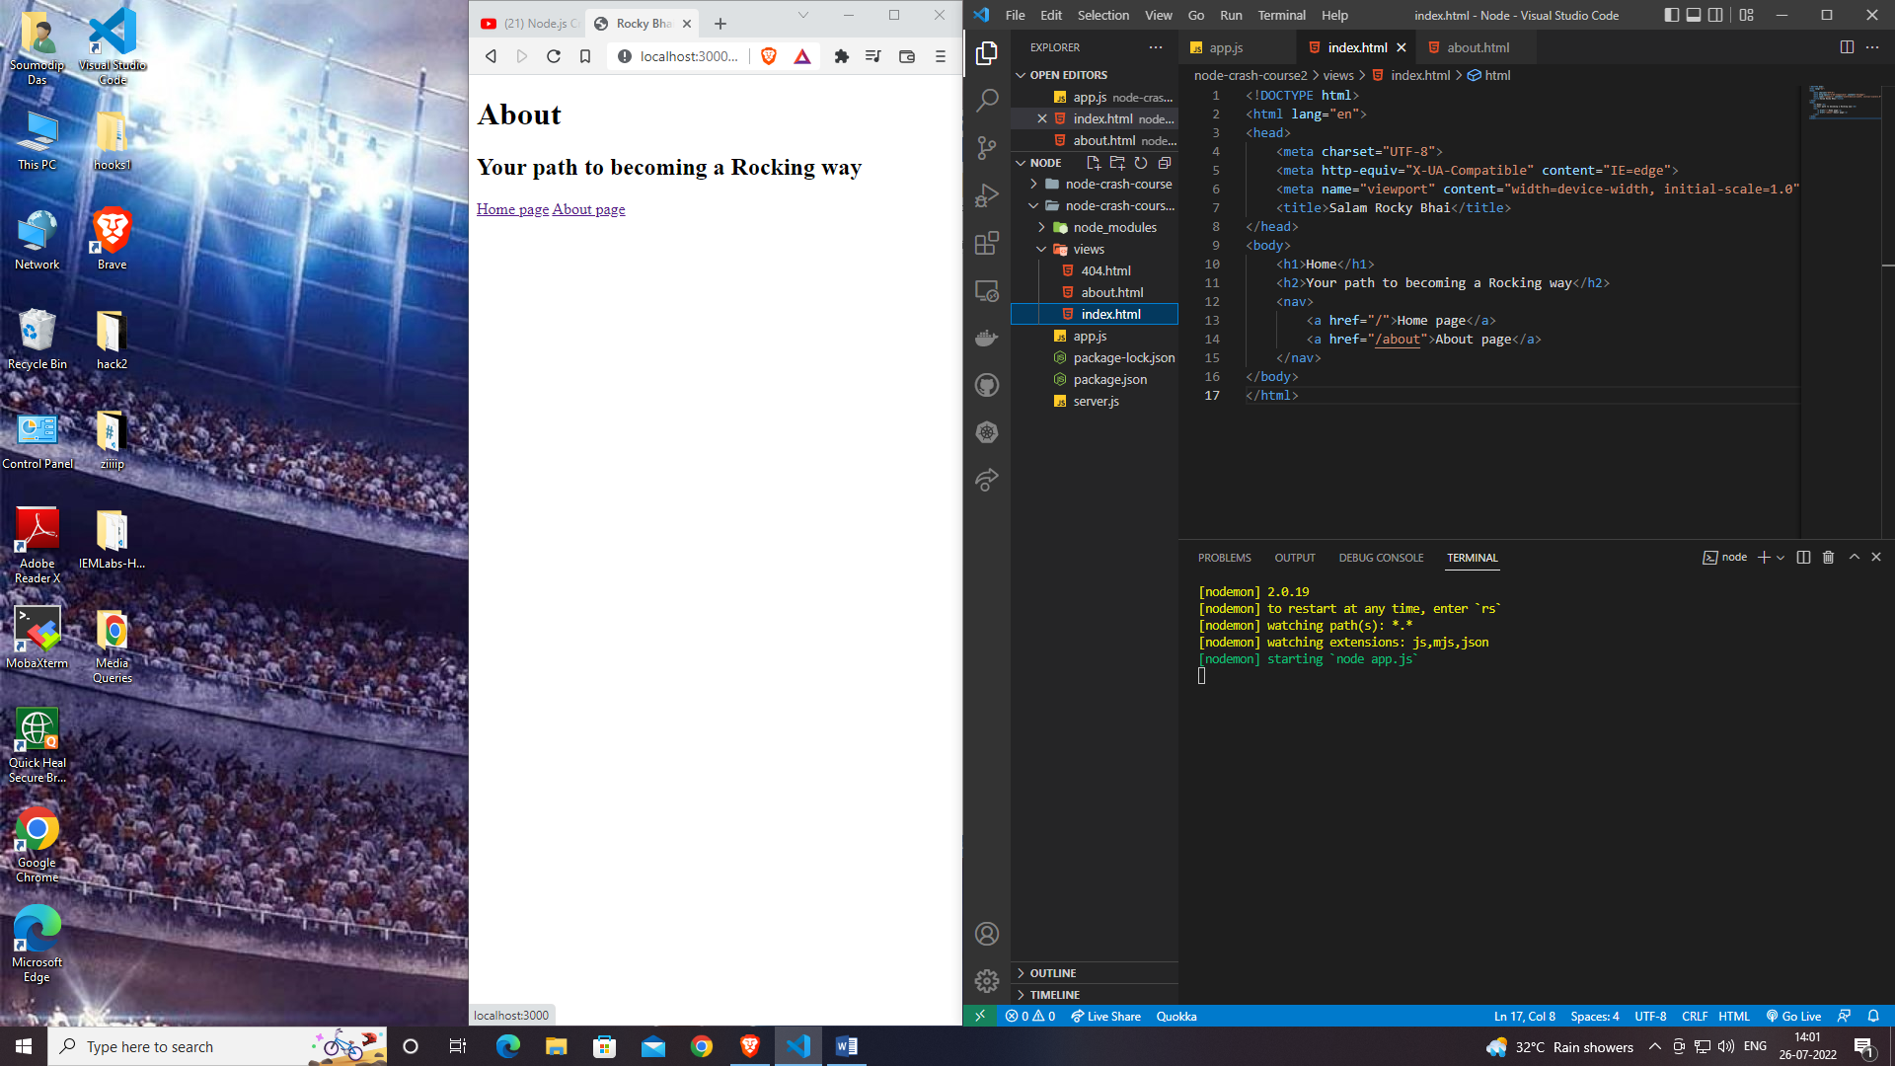

**Click**

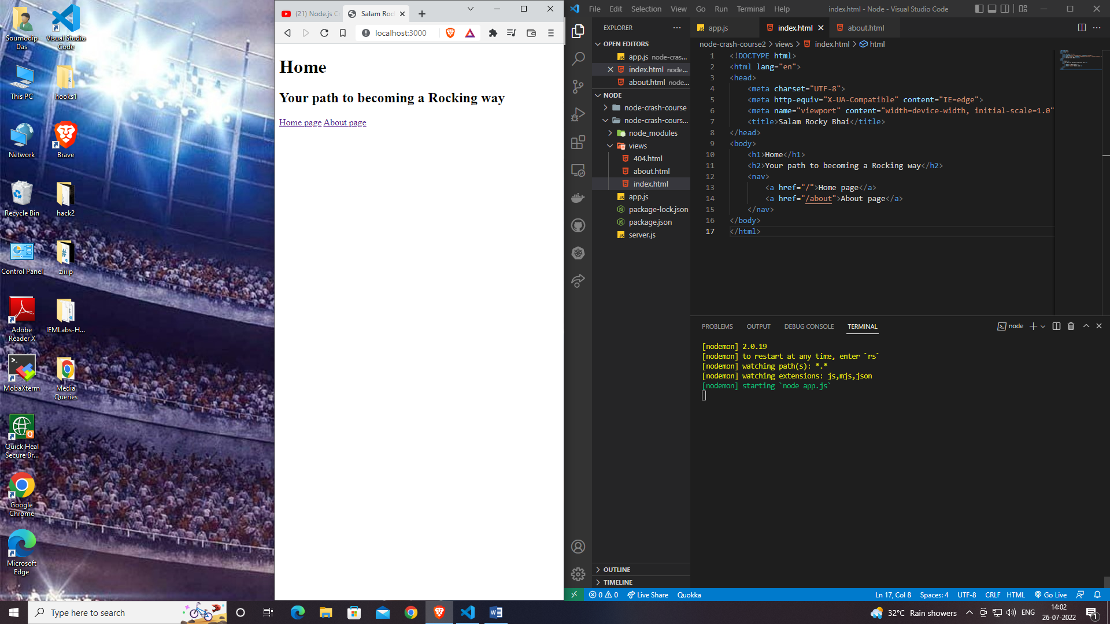

**Click**

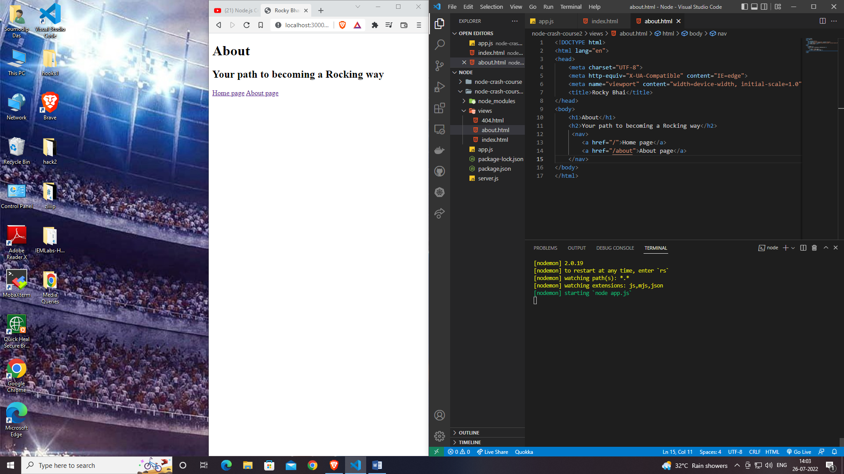

**Redirect & 404’s**

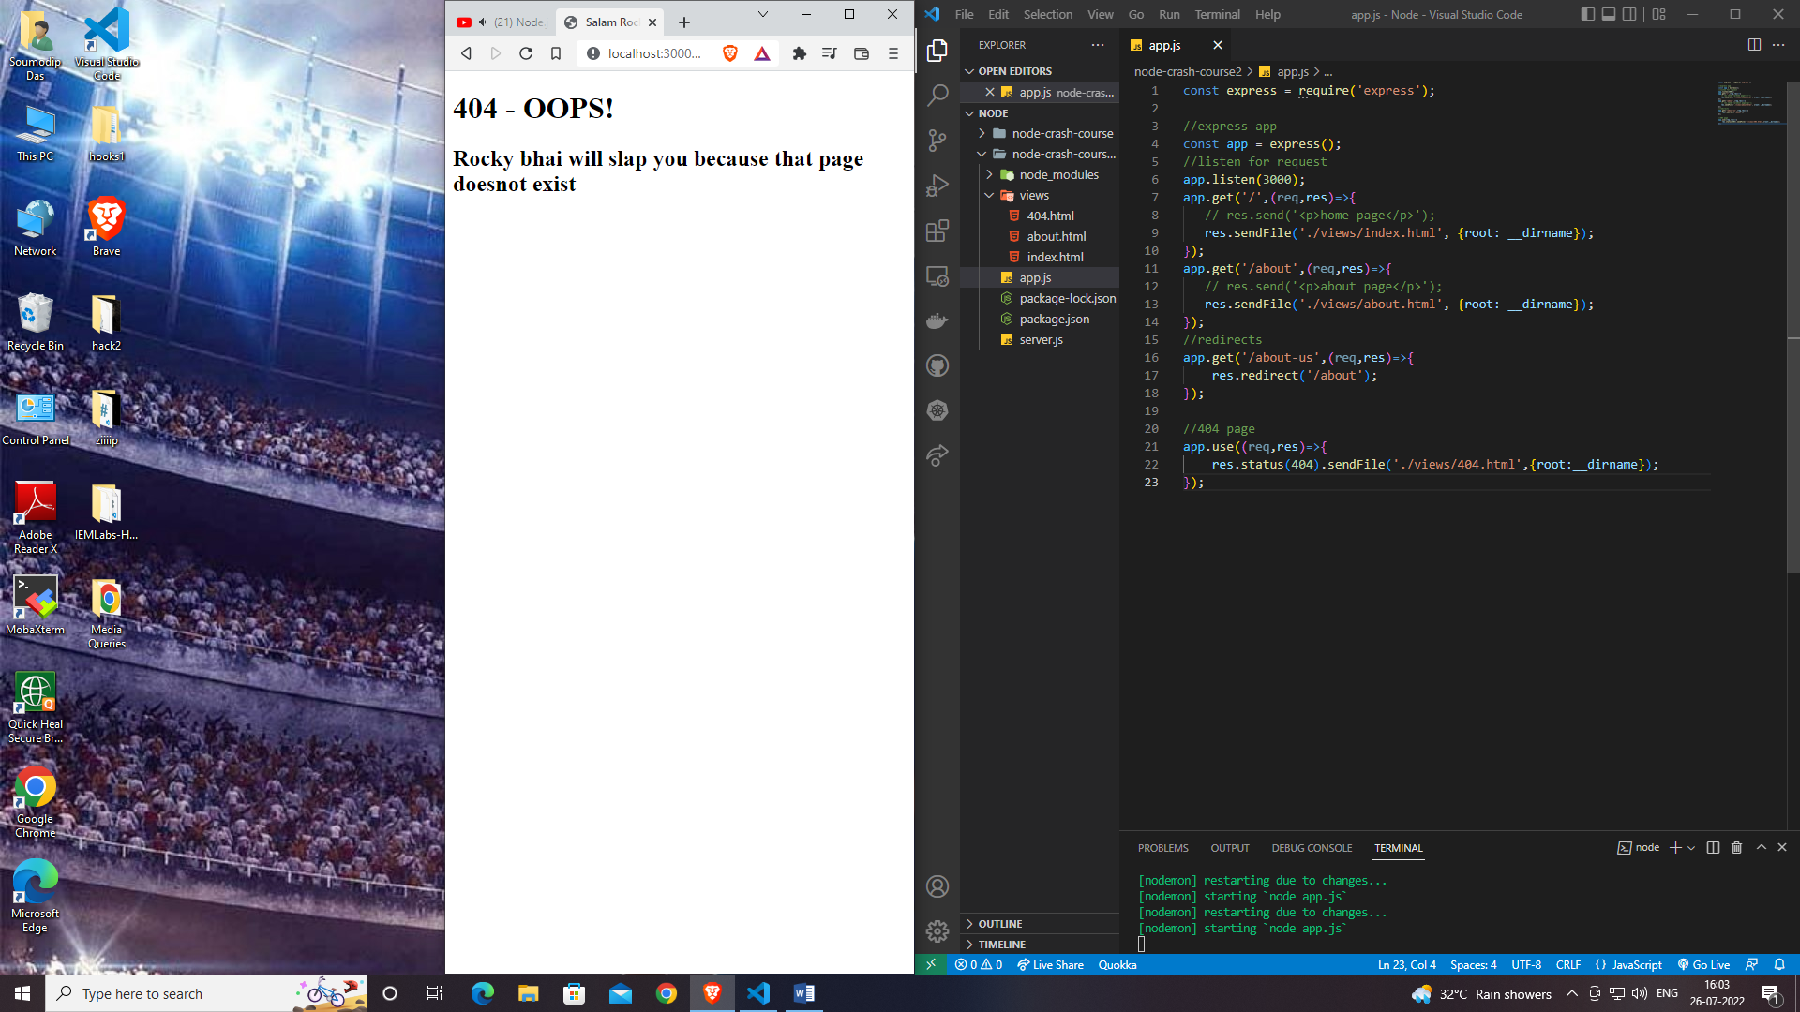

**EJS(Embedded Javascript Templating)**

**Installation: npm install ejs**

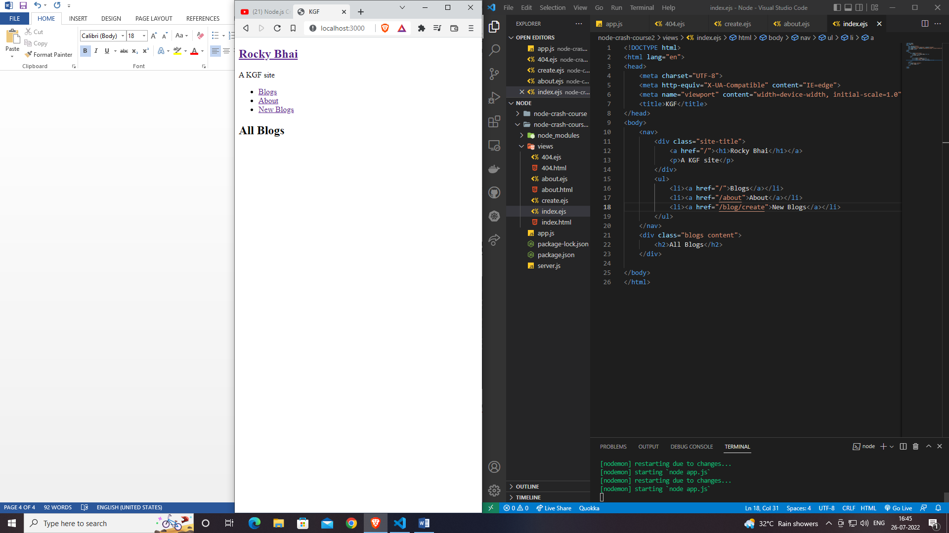

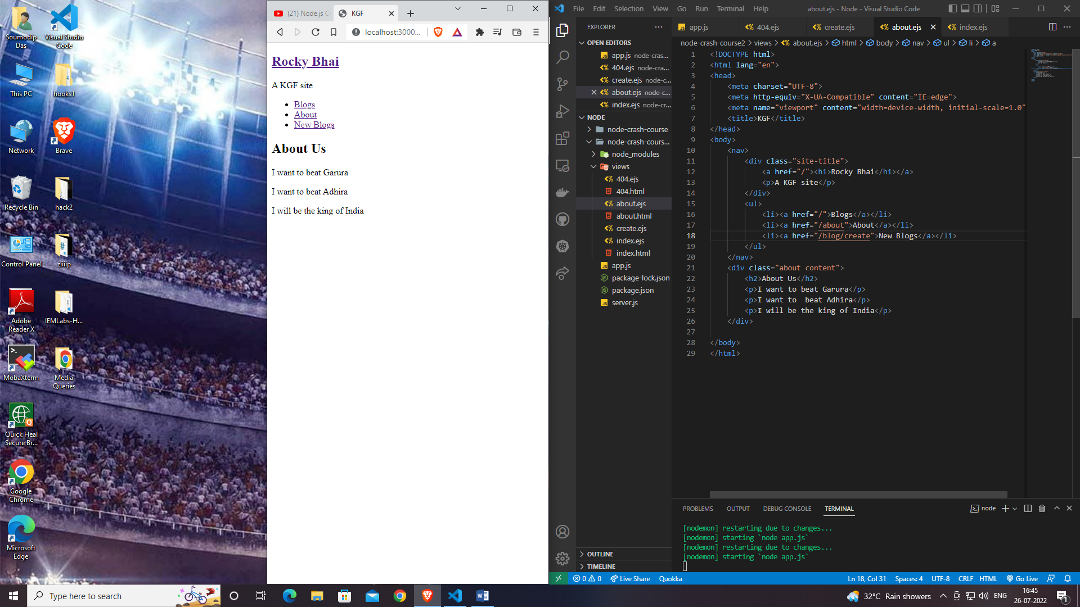

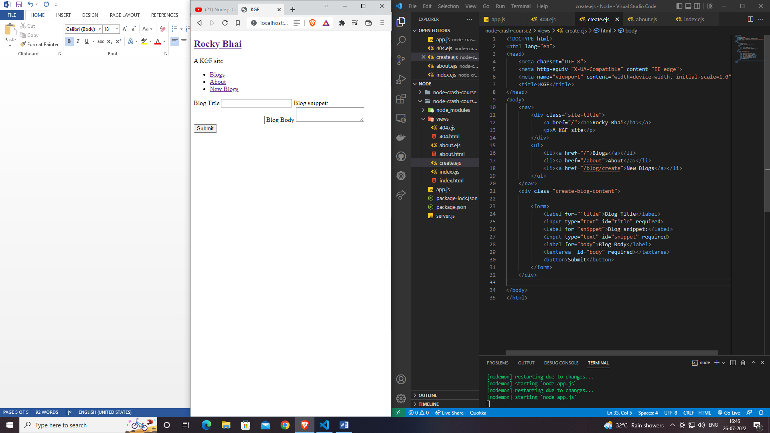

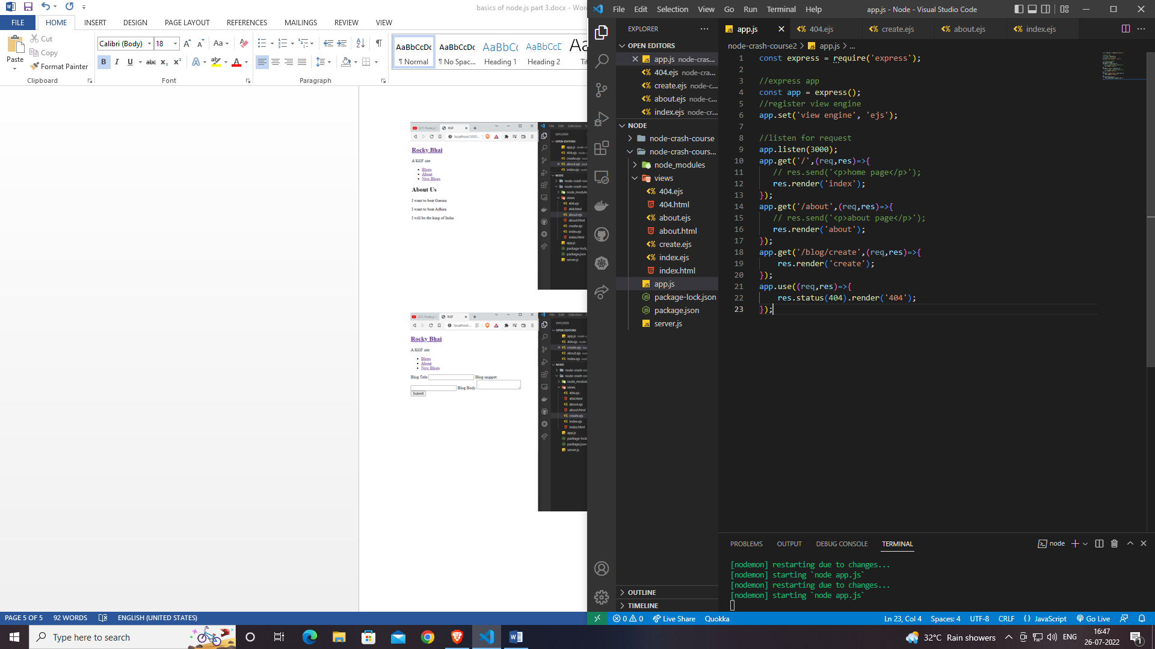

**Passing data into views**

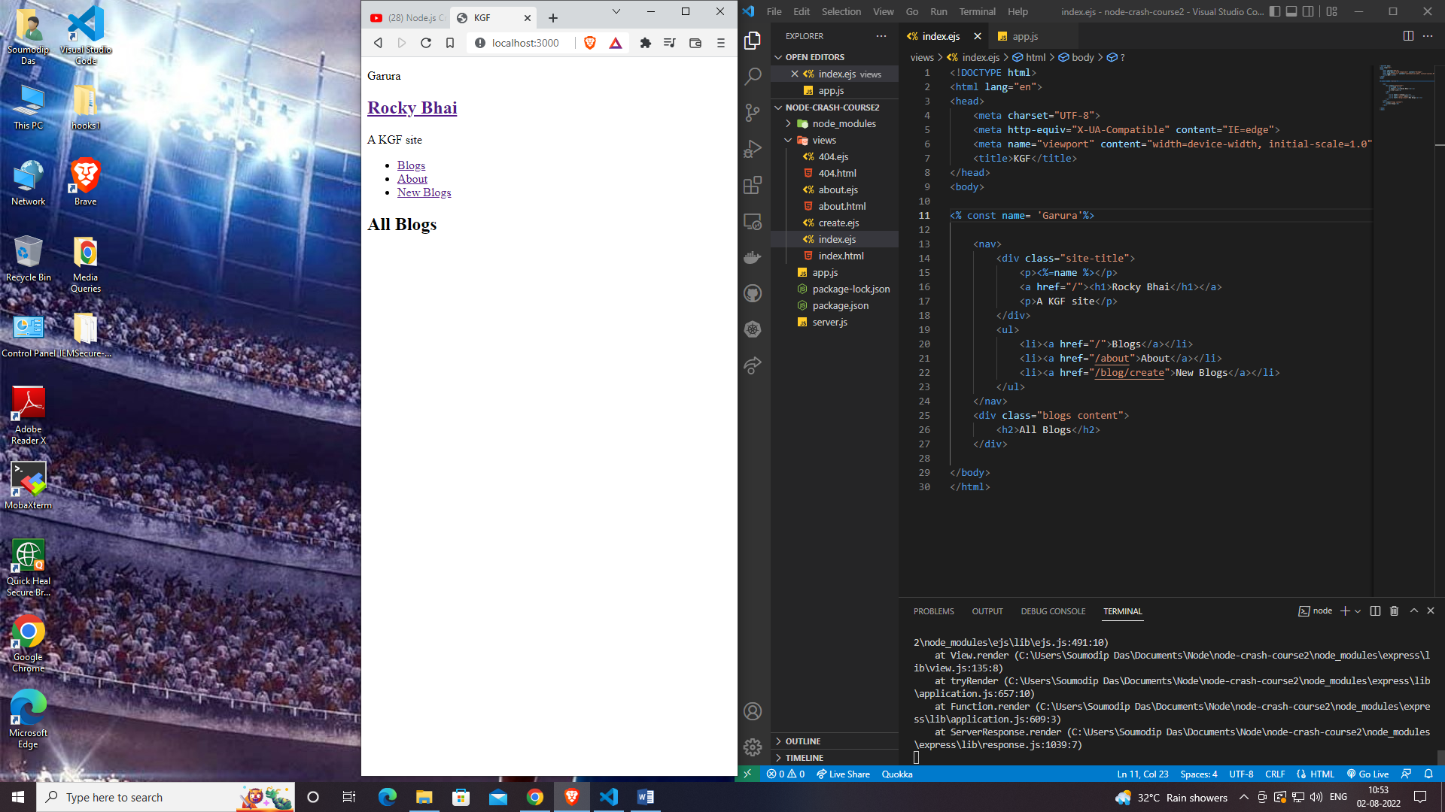

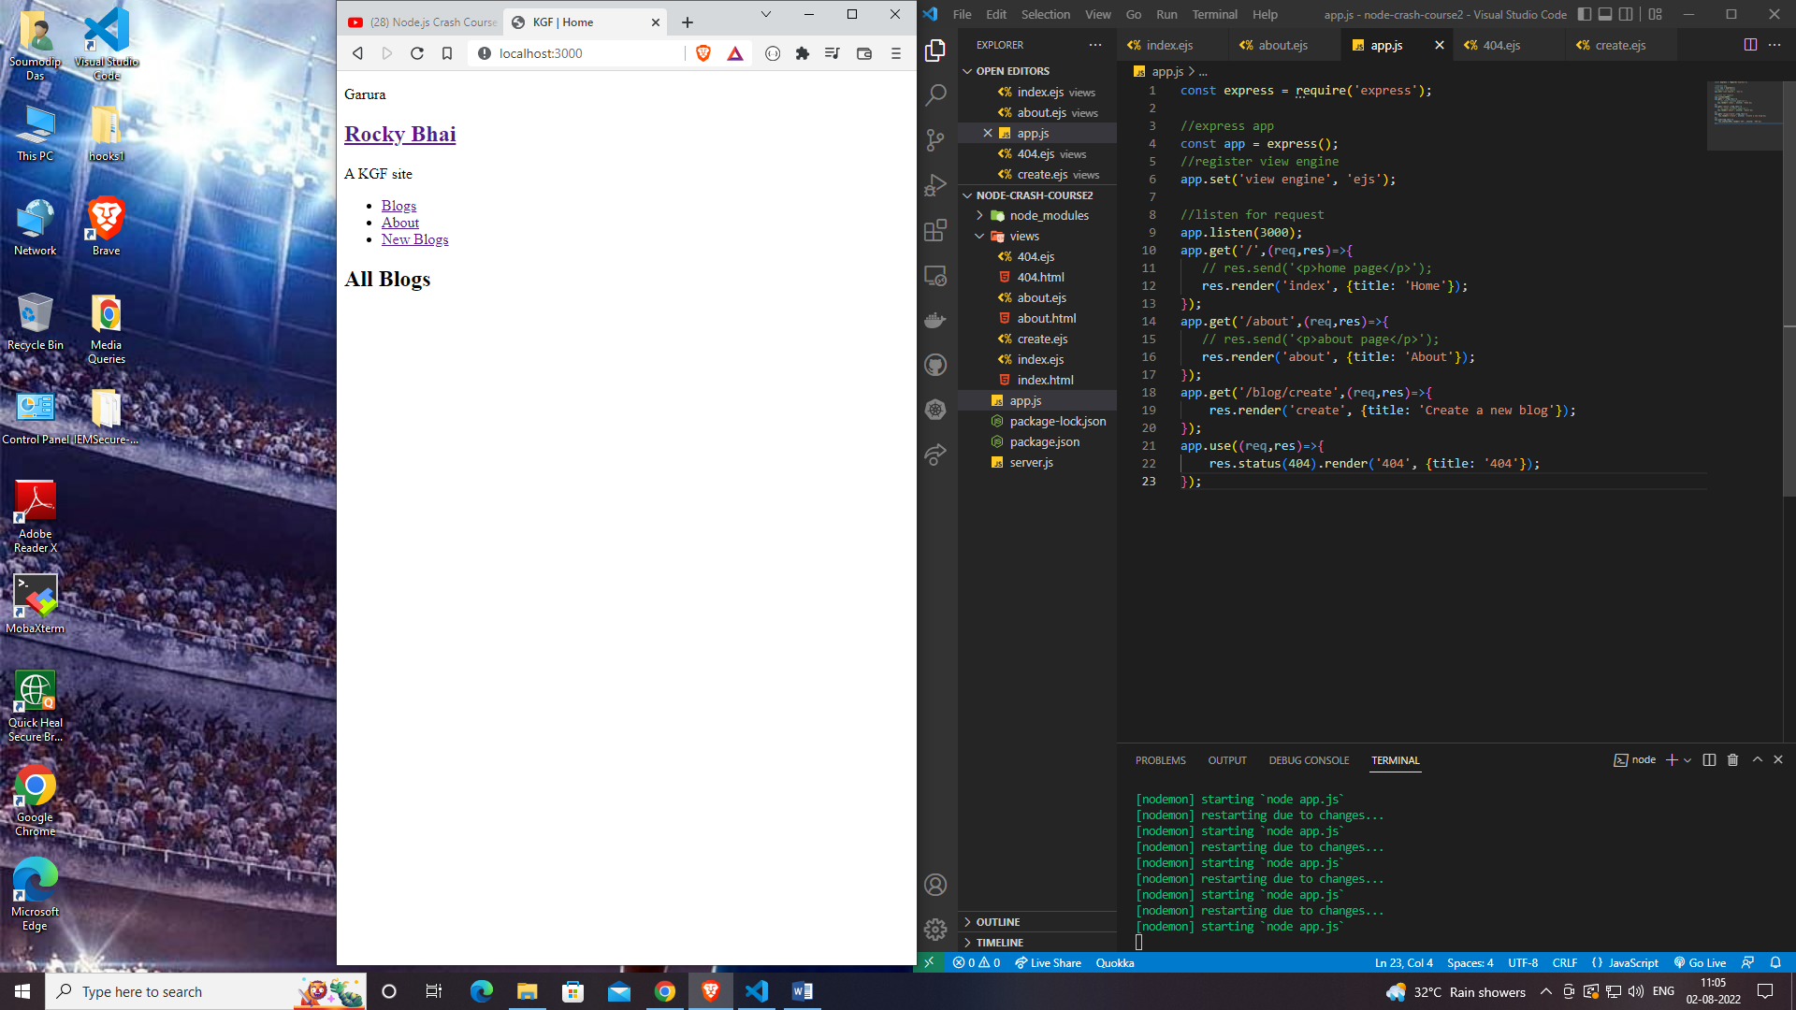

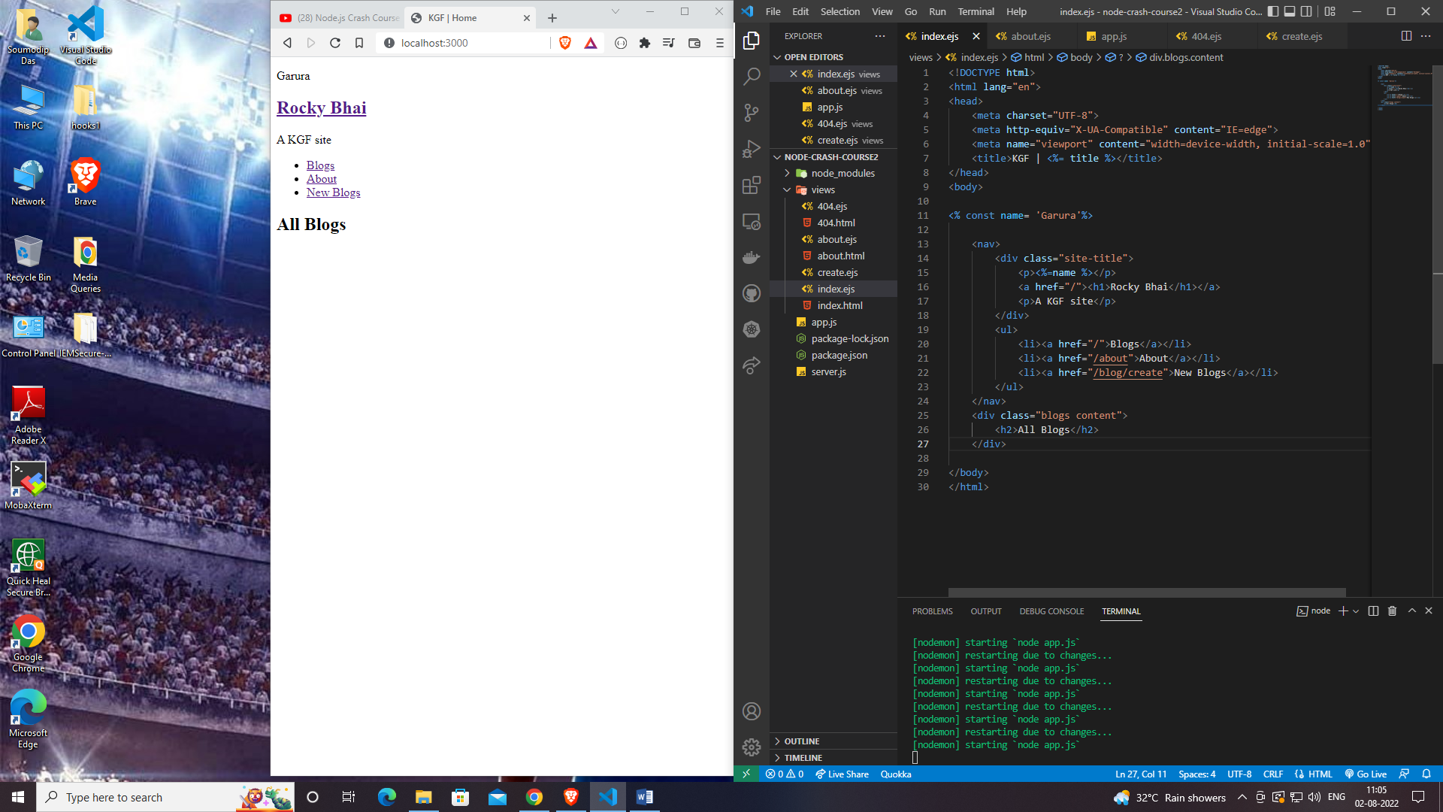

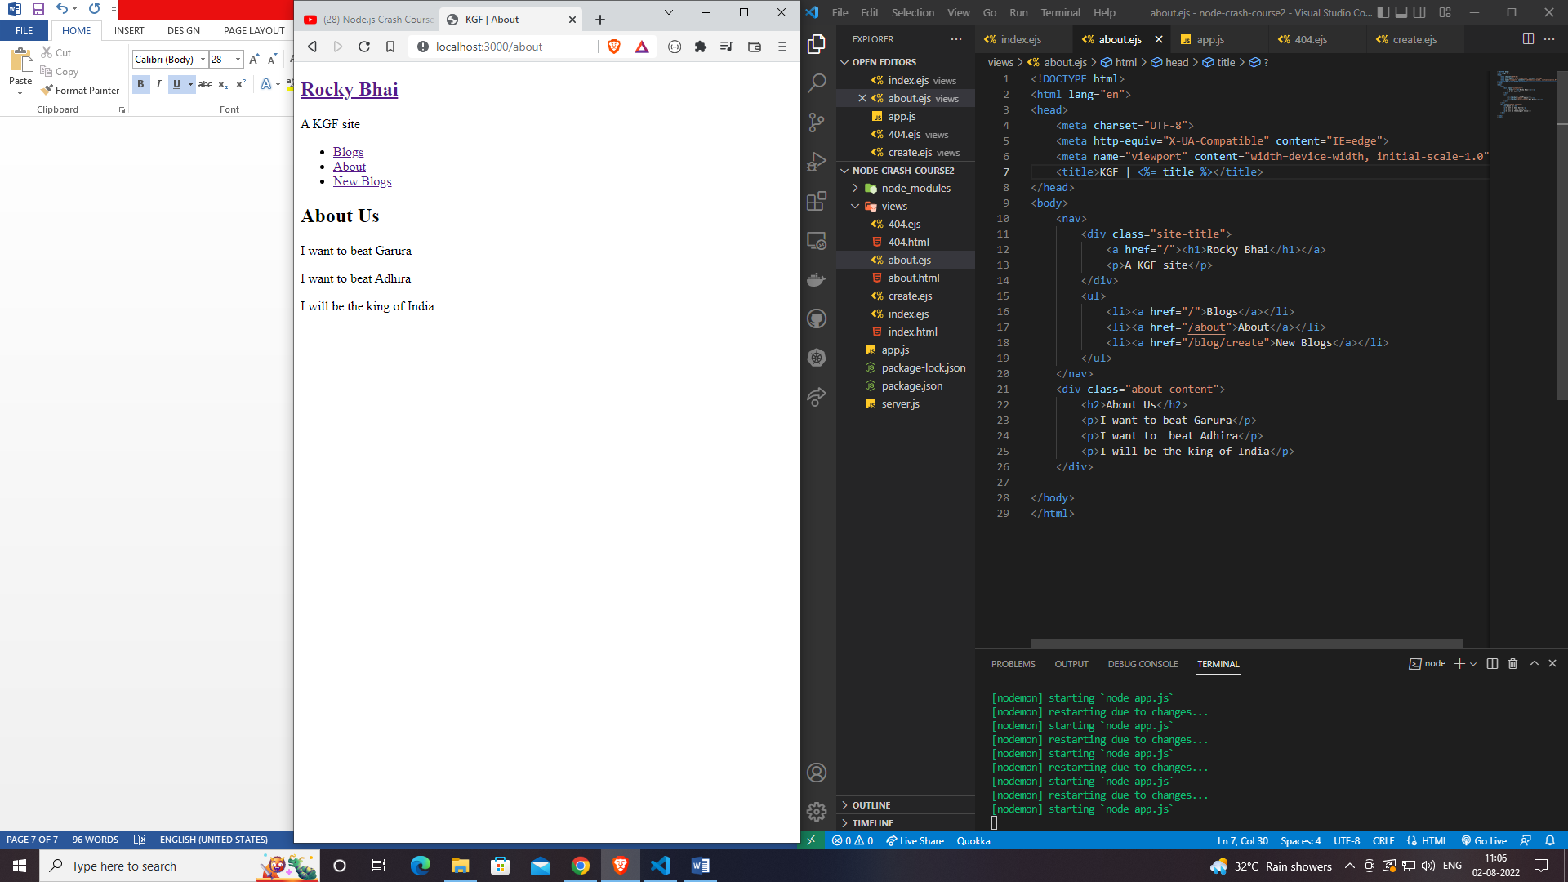

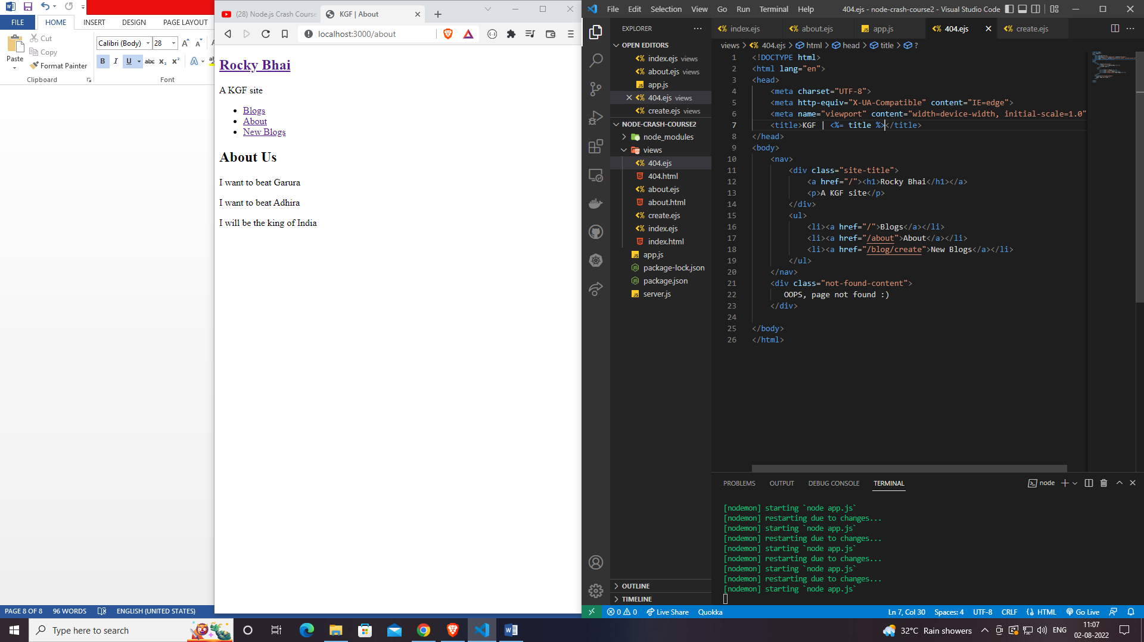

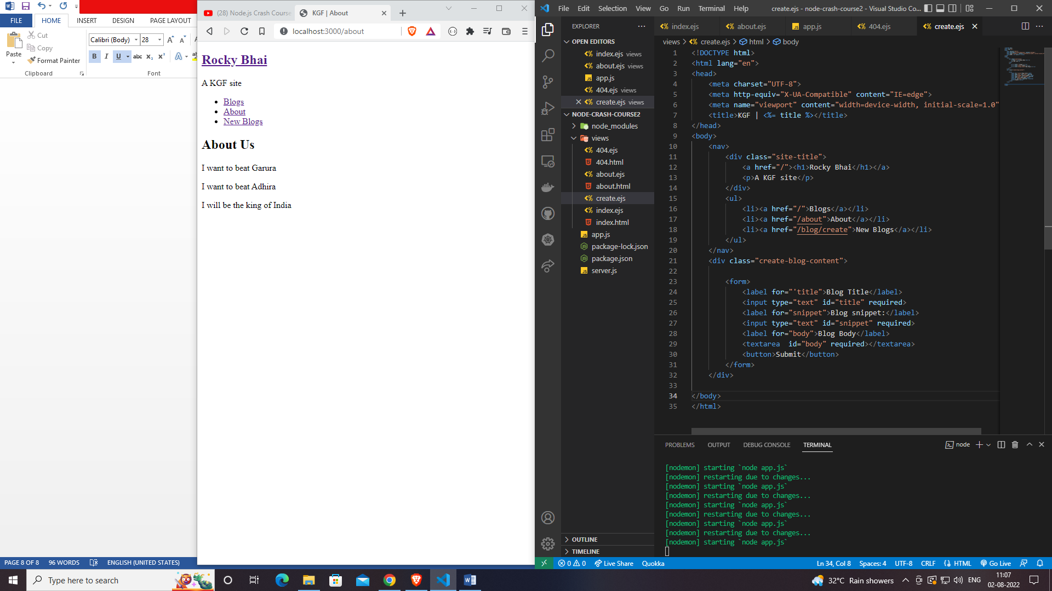

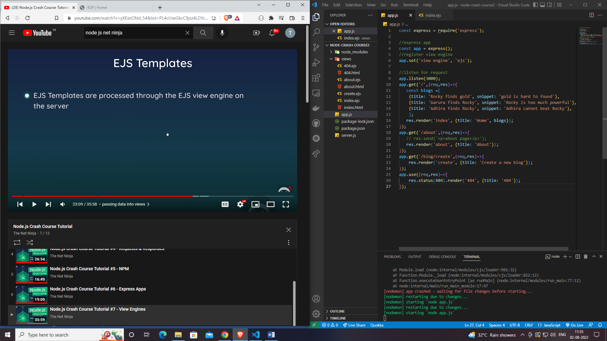

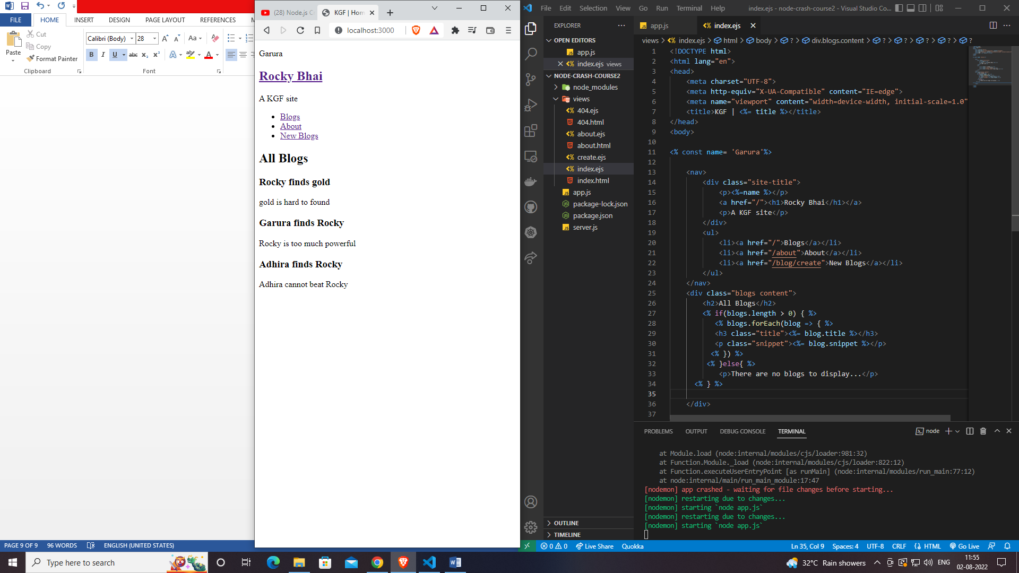

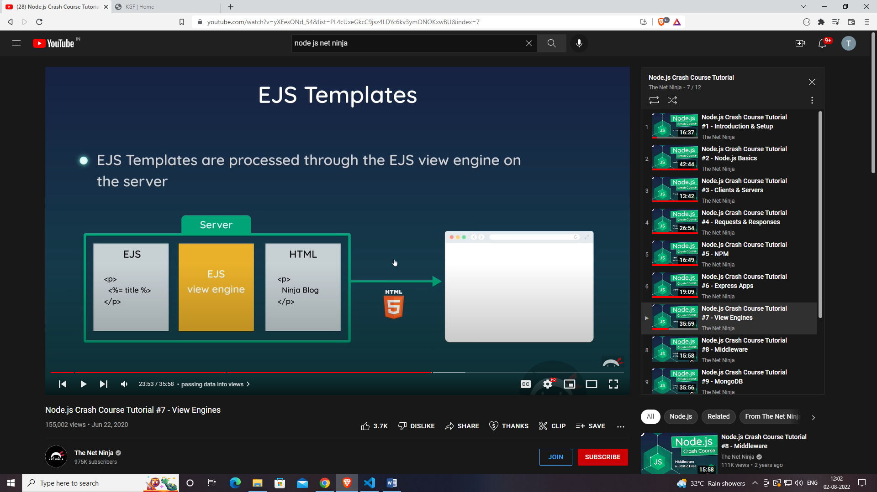

**Partials**

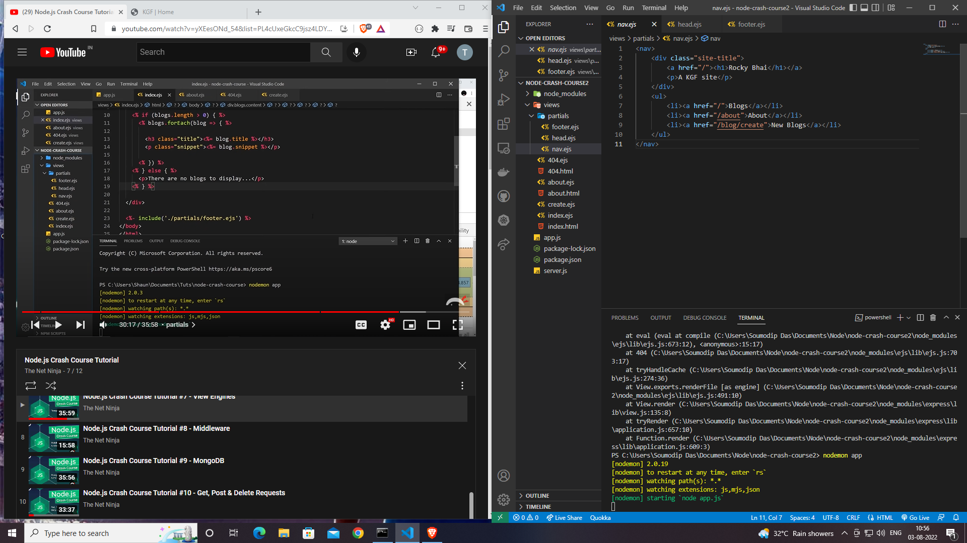

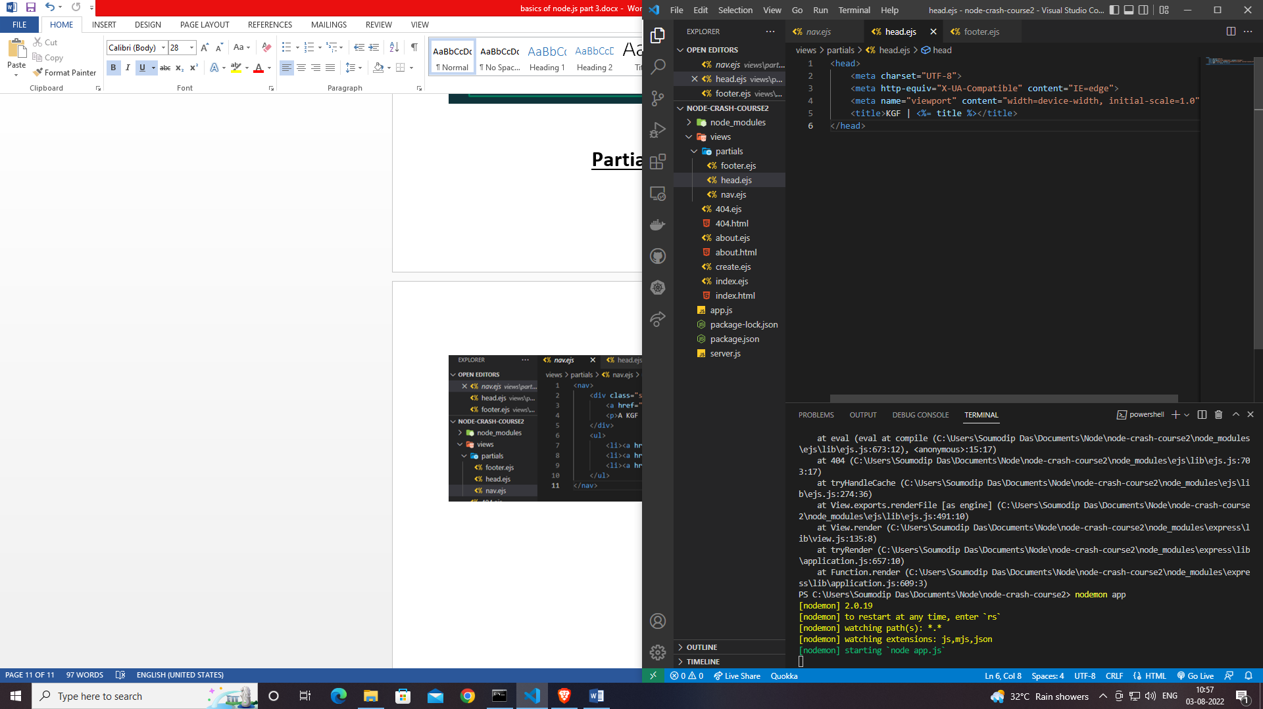

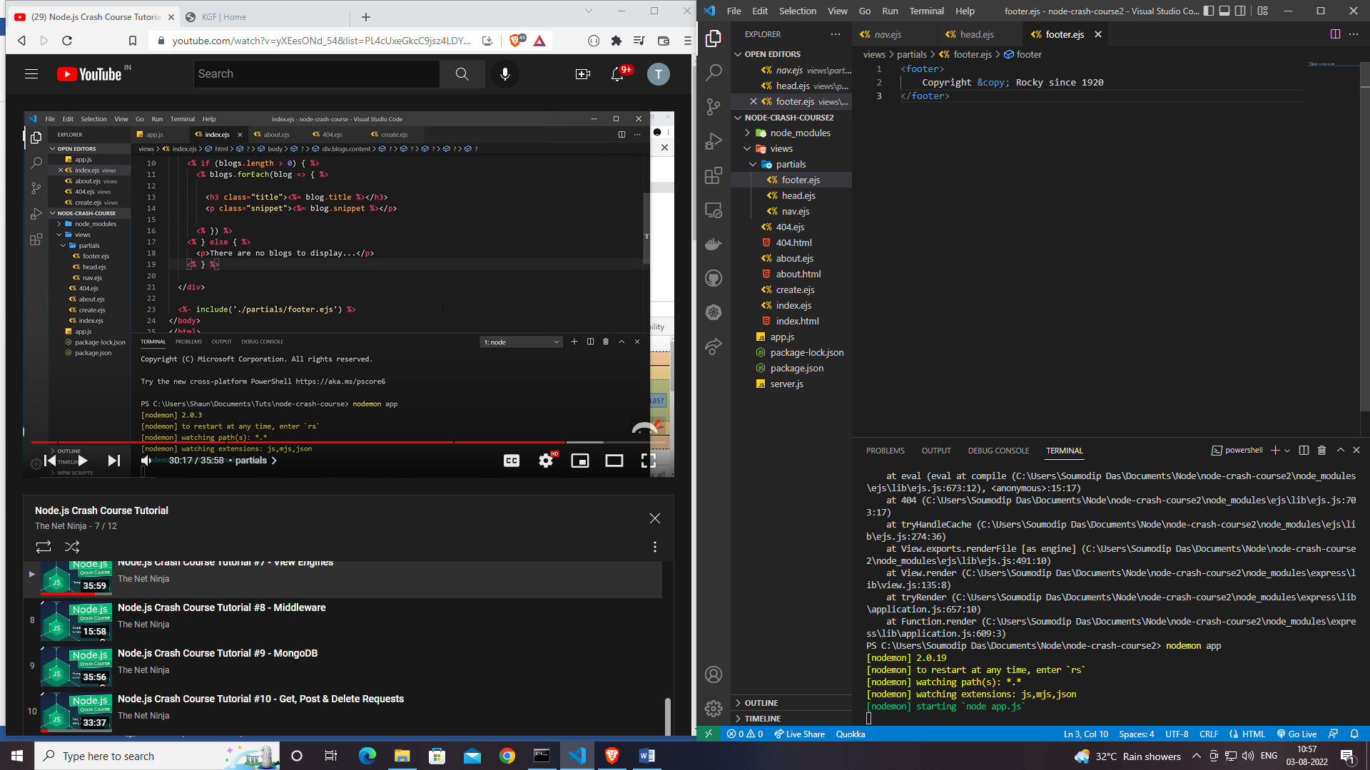

* For including those in ejs we need to write some syntaxes
* <%- include('./partials/nav.ejs')  %>
* <%- include('./partials/head.ejs') %>
* <%- include('./partials/footer.ejs')  %>

**Adding CSS**

<head>

    <meta charset="UTF-8">

    <meta http-equiv="X-UA-Compatible" content="IE=edge">

    <meta name="viewport" content="width=device-width, initial-scale=1.0">

    <title>KGF | <%= title %></title>

    <style>

       @import url('https://fonts.googleapis.com/css2?family=Lobster&display=swap');

    body{

      max-width: 1200px;

      margin: 20px auto;

      padding: 0 20px;

      font-family: 'Noto Serif', serif;

    }

    p, h1, h2, h3, a, ul{

      margin: 0;

      padding: 0;

      text-decoration: none;

      color: #222;

    }

    /* nav & footer styles */

    nav{

      display: flex;

      justify-content: space-between;

      margin-bottom: 60px;

      padding-bottom: 10px;

      border-bottom: 1px solid #ddd;

      text-transform: uppercase;

    }

    nav ul{

      display: flex;

      justify-content: space-between;

      align-items: flex-end;

    }

    nav li{

      list-style-type: none;

      margin-left: 20px;

    }

    nav h1{

      font-size: 3em;

    }

    nav p, nav a{

      color: #777;

      font-weight: 300;

    }

    footer{

      color: #777;

      text-align: center;

      margin: 80px auto 20px;

    }

    h2{

      margin-bottom: 40px;

    }

    h3{

      text-transform: capitalize;

      margin-bottom: 8px;

    }

    .content{

      margin-left: 20px;

    }

    /* index styles */

    /* details styles */

    /* create styles */

    .create-blog-content form{

      max-width: 400px;

      margin: 0 auto;

    }

    .create-blog-content input,

    .create-blog-content textarea{

      display: block;

      width: 100%;

      margin: 10px 0;

      padding: 8px;

    }

    .create-blog-content label{

      display: block;

      margin-top: 24px;

    }

    textarea{

      height: 120px;

    }

    .create-blog-content button{

      margin-top: 20px;

      background: crimson;

      color: white;

      padding: 6px;

      border: 0;

      font-size: 1.2em;

      cursor: pointer;

    }

    </style>

</head>

//ON head.ejs